**ASSIGNMENT-3**

**FUNDAMENTAL OF MACHINE LEARNING**

**NAME-** MUTTA DATTA SAI VISHNU MOHAN

**USN-** 22BTRAD0026

**QUES.** Load a dataset with (features of different scales) Boston Housing Dataset.

CODE:

import pandas as pd

# Load the Boston Housing dataset

boston_data = pd.read_csv('HousingData.csv')

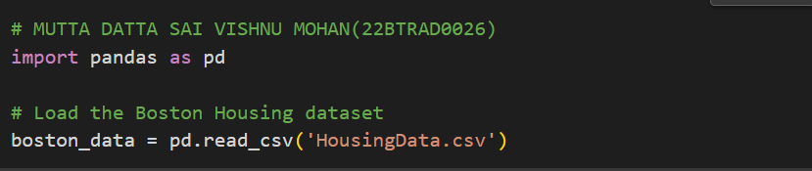

**QUES.** Apply Min-Max scaling to dataset

CODE:

from sklearn.preprocessing import MinMaxScaler

# Create the MinMaxScaler object

scaler = MinMaxScaler()

# Fit the scaler on the features

scaler.fit(boston_data[['CRIM', 'ZN', 'CHAS', 'NOX', 'INDUS', 'PTRATIO',

'MEDV', 'LSTAT', 'RAD', 'AGE']])

# Transform the features

boston_data_minmax = scaler.transform(boston_data[['CRIM', 'ZN', 'CHAS', 'NOX',

'INDUS', 'PTRATIO', 'MEDV',

'LSTAT', 'RAD', 'AGE']])

print(boston_data_minmax)

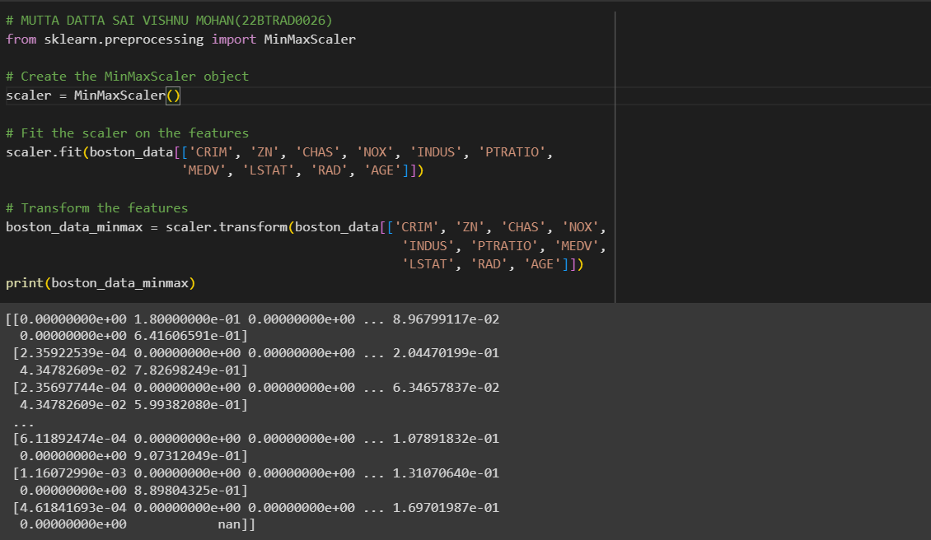

**QUES.** Apply Standardization to dataset.

CODE:

from sklearn.preprocessing import StandardScaler

# Create the StandardScaler object

scaler = StandardScaler()

# Fit the scaler on the features

scaler.fit(boston_data[['CRIM', 'ZN', 'CHAS', 'NOX', 'INDUS', 'PTRATIO',

'MEDV', 'LSTAT', 'RAD', 'AGE']])

# Transform the features

boston_data_std = scaler.transform(boston_data[['CRIM', 'ZN', 'CHAS', 'NOX',

'INDUS', 'PTRATIO', 'MEDV',

'LSTAT', 'RAD', 'AGE']])

print(boston_data_std)

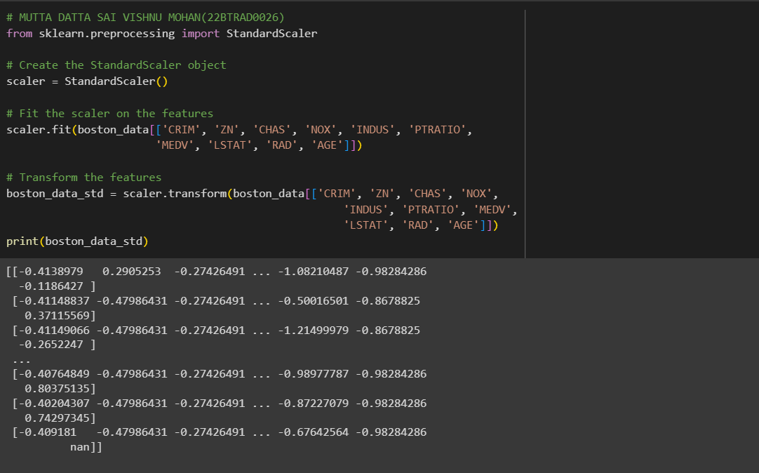

**QUES.** Apply Robust scaling to the dataset.

CODE:

from sklearn.preprocessing import RobustScaler

# Create the RobustScaler object

scaler = RobustScaler()

# Fit the scaler on the features

scaler.fit(boston_data[['CRIM', 'ZN', 'CHAS', 'NOX', 'INDUS', 'PTRATIO',

'MEDV', 'LSTAT', 'RAD', 'AGE']])

# Transform the features

boston_data_robust = scaler.transform(boston_data[['CRIM', 'ZN', 'CHAS', 'NOX',

'INDUS', 'PTRATIO', 'MEDV',

'LSTAT', 'RAD', 'AGE']])

print(boston_data_robust)

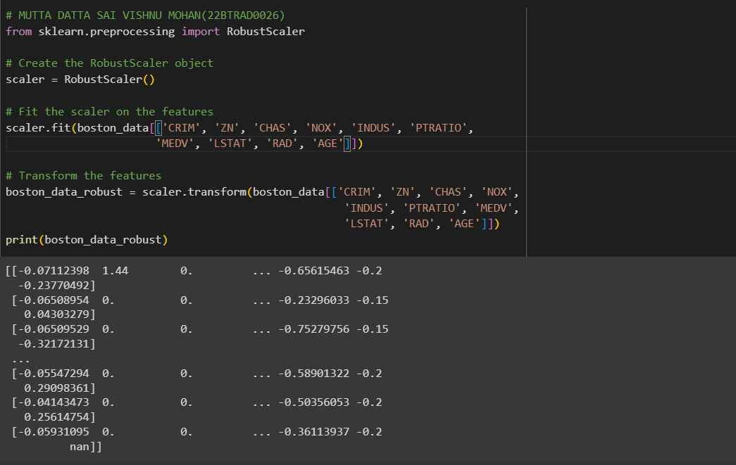

**QUES.** Assess the impact of scaling on the dataset.

CODE:

print('Statistical measures before scaling:')

print(boston_data.describe())

# Statistical measures after Min-Max scaling

print('Statistical measures after Min-Max scaling:')

print(pd.DataFrame(boston_data_minmax).describe())

# Statistical measures after standardization

print('Statistical measures after standardization:')

print(pd.DataFrame(boston_data_std).describe())

# Statistical measures after robust scaling

print('Statistical measures after robust scaling:')

print(pd.DataFrame(boston_data_robust).describe())

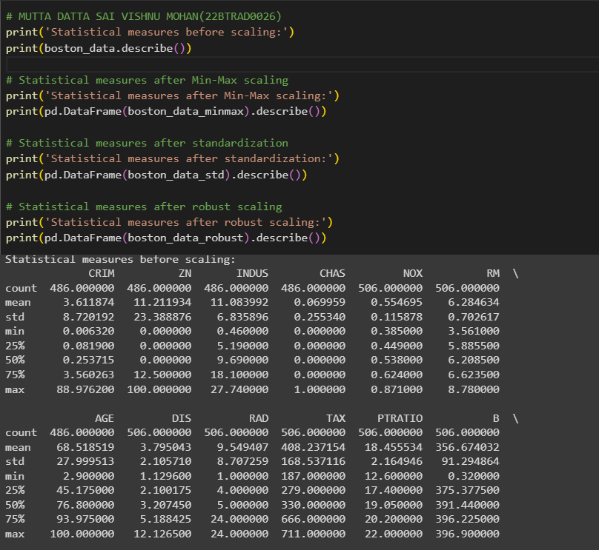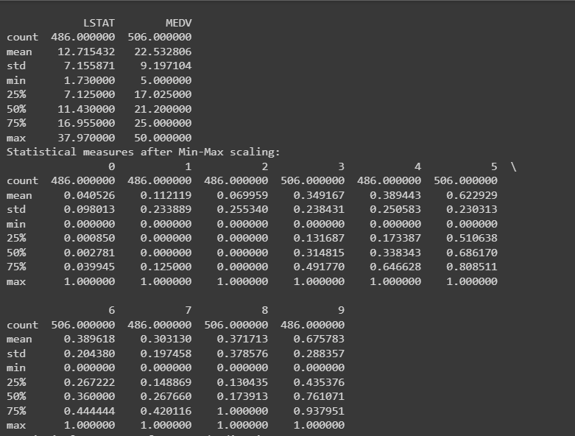

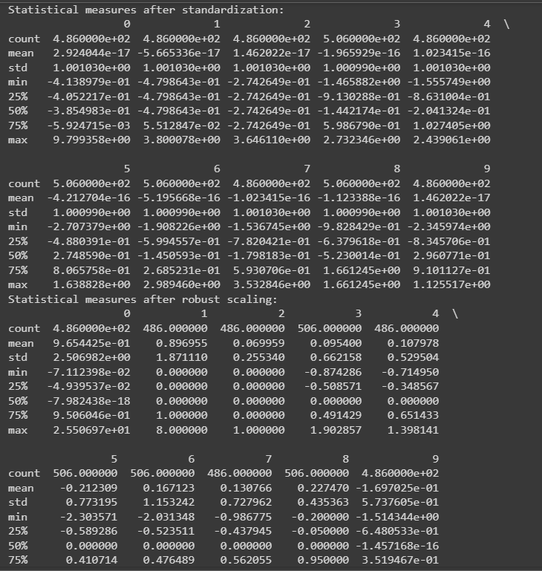

GITHUB:

https://github.com/MDSVISHNUMOHAN/MACHINE-LEARNING